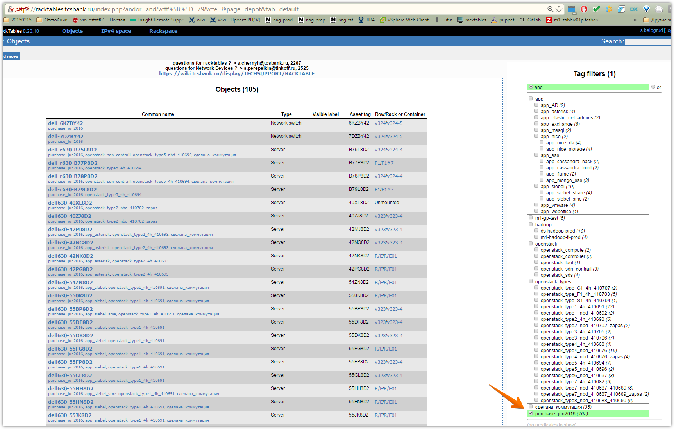

Objects (105)

Common name | Type | Visible label | Asset tag | Row/Rack or Container
dell-6KZBY42  purchase_jun2016 | Network switch |  | 6KZBY42 | v324/v324-5
dell-7DZBY42  purchase_jun2016 | Network switch |  | 7DZBY42 | v324/v324-5
dell-r630-B75L8D2  purchase_jun2016, openstack_sdn_contrail, openstack_type5_nbd_410696, сделана_коммутация | Server |  | B75L8D2 | v324/v324-4
dell-r630-B77P8D2  purchase_jun2016, openstack_type5_4h_410694 | Server |  | B77P8D2 | F1/F1#7
dell-r630-B78P8D2  purchase_jun2016, openstack_sdn_contrail, openstack_type5_4h_410694, сделана_коммутация | Server |  | B78P8D2 | v324/v324-4
dell-r630-B79L8D2  purchase_jun2016, openstack_type5_4h_410694 | Server |  | B79L8D2 | F1/F1#7
dell630-40XL8D2  purchase_jun2016, openstack_type2_nbd_410702_zapas | Server |  | 40XL8D2 | Unmounted
dell630-40ZJ8D2  purchase_jun2016, openstack_type2_nbd_410702_zapas | Server |  | 40ZJ8D2 | v323/v323-4
dell630-42MJ8D2  purchase_jun2016, app_asterisk, openstack_type2_4h_410693, сделана_коммутация | Server |  | 42MJ8D2 | v323/v323-4
dell630-42NG8D2  purchase_jun2016, app_asterisk, openstack_type2_4h_410693, сделана_коммутация | Server |  | 42NG8D2 | v323/v323-4
dell630-42NK8D2  purchase_jun2016, app_asterisk, openstack_type2_4h_410693 | Server |  | 42NK8D2 | R/E/R/E01
dell630-42PG8D2  purchase_jun2016, app_asterisk, openstack_type2_4h_410693 | Server |  | 42PG8D2 | R/E/R/E01
dell630-54ZN8D2  purchase_jun2016, app_siebel, openstack_type1_4h_410691, сделана_коммутация | Server |  | 54ZN8D2 | R/E/R/E01
dell630-550K8D2  purchase_jun2016, app_siebel, openstack_type1_4h_410691, сделана_коммутация | Server |  | 550K8D2 | R/E/R/E01
dell630-55BP8D2  purchase_jun2016, app_siebel_sme, openstack_type1_4h_410691, сделана_коммутация | Server |  | 55BP8D2 | v323/v323-4
dell630-55DF8D2  purchase_jun2016, app_siebel, openstack_type1_4h_410691 | Server |  | 55DF8D2 | v323/v323-4
dell630-55DK8D2  purchase_jun2016, app_siebel, openstack_type1_4h_410691 | Server |  | 55DK8D2 | v323/v323-4
dell630-55FG8D2  purchase_jun2016, app_siebel, openstack_type1_4h_410691, сделана_коммутация | Server |  | 55FG8D2 | R/E/R/E01
dell630-55FP8D2  purchase_jun2016, app_siebel, openstack_type1_4h_410691 | Server |  | 55FP8D2 | v323/v323-4
dell630-55GL8D2  purchase_jun2016, app_siebel, openstack_type1_4h_410691 | Server |  | 55GL8D2 | v323/v323-4
dell630-55HH8D2  purchase_jun2016, app_siebel_sme, openstack_type1_4h_410691, сделана_коммутация | Server |  | 55HH8D2 | R/E/R/E01
dell630-55HN8D2  purchase_jun2016, app_siebel, openstack_type1_4h_410691, сделана_коммутация | Server |  | 55HN8D2 | R/E/R/E01
dell630-55JK8D2  purchase_jun2016, app_siebel, openstack_type1_4h_410691, сделана_коммутация | Server |  | 55JK8D2 | R/E/R/E01
dell630-55JP8D2  purchase_jun2016, app_siebel, openstack_type1_4h_410691 | Server |  | 55JP8D2 | v323/v323-4
dell630-55KK8D2  purchase_jun2016, openstack_compute, openstack_type1_nbd_410692, сделана_коммутация | Server |  | 55KK8D2 | v324/v324-4
dell630-55KN8D2  purchase_jun2016, openstack_compute, openstack_type1_nbd_410692, сделана_коммутация | Server |  | 55KN8D2 | v324/v324-4
dell630-5VHP8D2  purchase_jun2016, openstack_controller, openstack_type6_nbd_410697, сделана_коммутация | Server |  | 5VHP8D2 | v324/v324-4
dell630-5VJH8D2  purchase_jun2016, openstack_controller, openstack_type6_nbd_410697, сделана_коммутация | Server |  | 5VJH8D2 | v324/v324-4
dell630-5VJL8D2  purchase_jun2016, openstack_controller, openstack_type6_nbd_410697, сделана_коммутация | Server |  | 5VJL8D2 | v324/v324-4
dell630-B76P8D2  purchase_jun2016, openstack_fuel, openstack_sdn_contrail, openstack_type5_nbd_410696, сделана_коммутация | Server |  | B76P8D2 | v324/v324-4
dell630-B7BN8D2  purchase_jun2016, app_cassandra_front, openstack_type5_4h_410694, сделана_коммутация | Server |  | B7BN8D2 | R/E/R/E08
dell630-B7DF8D2  purchase_jun2016, app_cassandra_front, openstack_type5_4h_410694, сделана_коммутация | Server |  | B7DF8D2 | R/E/R/E08
dell730-6W4L8D2  purchase_jun2016, ds-hadoop-prod, openstack_type4_nbd_410676 | Server |  | 6W4L8D2 | R/H/R/H3
dell730-6W4P8D2  purchase_jun2016, app_siebel_share, openstack_type4_4h_410668, сделана_коммутация | Server |  | 6W4P8D2 | R/F/R/F10
dell730-6W6G8D2  purchase_jun2016, app_siebel_share, openstack_type4_4h_410668, сделана_коммутация | Server |  | 6W6G8D2 | R/F/R/F10
dell730-6W6H8D2  purchase_jun2016, ds-hadoop-prod, openstack_type4_nbd_410676 | Server |  | 6W6H8D2 | R/H/R/H3
dell730-6W6M8D2  purchase_jun2016, openstack_sds, openstack_type4_nbd_410676, сделана_коммутация | Server |  | 6W6M8D2 | v324/v324-4
dell730-6W6P8D2  purchase_jun2016, app_siebel_share, openstack_type4_4h_410668 | Server |  | 6W6P8D2 | v321/v321-2
dell730-6W7F8D2  purchase_jun2016, openstack_sds, openstack_type4_nbd_410676, сделана_коммутация | Server |  | 6W7F8D2 | v324/v324-4
dell730-6W7G8D2  purchase_jun2016, app_siebel_share, openstack_type4_4h_410668 | Server |  | 6W7G8D2 | v321/v321-2
dell730-6ZFG8D2  purchase_jun2016, app_mssql, openstack_type7_4h_410682 | Server |  | 6ZFG8D2 | R/F/R/F11
dell730-6ZFJ8D2  purchase_jun2016, app_nice, openstack_type7_4h_410682 | Server |  | 6ZFJ8D2 | v321/v321-2
dell730-6ZFM8D2  purchase_jun2016, app_nice_rta, openstack_type7_4h_410682, сделана_коммутация | Server |  | 6ZFM8D2 | R/F/R/F10
dell730-6ZGH8D2  purchase_jun2016, app_nice_rta, openstack_type7_4h_410682, сделана_коммутация | Server |  | 6ZGH8D2 | R/F/R/F10
dell730-6ZGL8D2  purchase_jun2016, app_nice_rta, openstack_type7_4h_410682 | Server |  | 6ZGL8D2 | v321/v321-2
dell730-6ZHH8D2  purchase_jun2016, app_nice_rta, openstack_type7_4h_410682 | Server |  | 6ZHH8D2 | v321/v321-2
dell730-6ZHM8D2  purchase_jun2016, app_mssql, openstack_type7_4h_410682 | Server |  | 6ZHM8D2 | v321/v321-2
dell730-6ZHP8D2  purchase_jun2016, app_exchange, openstack_type8_nbd_410688_410690 | Server |  | 6ZHP8D2 | v321/v321-2
dell730-6ZJK8D2  purchase_jun2016, app_nice, openstack_type7_4h_410682, сделана_коммутация | Server |  | 6ZJK8D2 | R/F/R/F10
dell730-6ZJP8D2  purchase_jun2016, app_exchange, openstack_type8_nbd_410688_410690 | Server |  | 6ZJP8D2 | R/F/R/F11
dell730-6ZKN8D2  purchase_jun2016, app_exchange, openstack_type8_nbd_410688_410690 | Server |  | 6ZKN8D2 | v321/v321-2
dell730-6ZLL8D2  purchase_jun2016, app_exchange, openstack_type8_nbd_410688_410690 | Server |  | 6ZLL8D2 | R/E/R/E03
dell730-6ZMF8D2  purchase_jun2016, app_exchange, openstack_type8_nbd_410688_410690 | Server |  | 6ZMF8D2 | R/E/R/E01
dell730-6ZMH8D2  purchase_jun2016, m1-gp-test, openstack_type7_nbd_410687_410689 | Server |  | 6ZMH8D2 | v324/v324-6
dell730-6ZMP8D2  purchase_jun2016, app_exchange, openstack_type8_nbd_410688_410690 | Server |  | 6ZMP8D2 | v321/v321-2
dell730-6ZNG8D2  purchase_jun2016, m1-gp-test, openstack_type7_nbd_410687_410689 | Server |  | 6ZNG8D2 | v324/v324-6
dell730-6ZNM8D2  purchase_jun2016, m1-gp-test, openstack_type7_nbd_410687_410689 | Server |  | 6ZNM8D2 | v324/v324-6
dell730-6ZNP8D2  purchase_jun2016, app_exchange, openstack_type8_nbd_410688_410690 | Server |  | 6ZNP8D2 | v321/v321-2
dell730-6ZPH8D2  purchase_jun2016, m1-gp-test, openstack_type7_nbd_410687_410689 | Server |  | 6ZPH8D2 | v324/v324-6
dell730-6ZPM8D2  purchase_jun2016, app_exchange, openstack_type8_nbd_410688_410690 | Server |  | 6ZPM8D2 | R/E/R/E03
dell730-6ZPN8D2  purchase_jun2016, m1-gp-test, openstack_type7_nbd_410687_410689 | Server |  | 6ZPN8D2 | v324/v324-6
dell730-6ZQG8D2  purchase_jun2016, m1-gp-test, openstack_type7_nbd_410687_410689 | Server |  | 6ZQG8D2 | v324/v324-6
dell730-6ZQL8D2  purchase_jun2016, m1-gp-test, openstack_type7_nbd_410687_410689 | Server |  | 6ZQL8D2 | v324/v324-6
dell730-6ZRG8D2  purchase_jun2016, m1-gp-test, openstack_type7_nbd_410687_410689 | Server |  | 6ZRG8D2 | v324/v324-6
dell730-6ZSF8D2  purchase_jun2016, openstack_type7_nbd_410687_410689_zapas | Server |  | 6ZSF8D2 | Unmounted
dell730-6ZSM8D2  purchase_jun2016, openstack_type7_nbd_410687_410689_zapas | Server |  | 6ZSM8D2 | v323/v323-4
dell730-809L8D2  purchase_jun2016, openstack_type3_nbd_410706 | Server |  | 809L8D2 | v324/v324-8
dell730-809P8D2  purchase_jun2016, m1-hadoop-ti-prod, openstack_type3_nbd_410706 | Server |  | 809P8D2 | v324/v324-8
dell730-80BJ8D2  purchase_jun2016, m1-hadoop-ti-prod, openstack_type3_nbd_410706 | Server |  | 80BJ8D2 | v324/v324-8
dell730-80BM8D2  purchase_jun2016, m1-hadoop-ti-prod, openstack_type3_nbd_410706 | Server |  | 80BM8D2 | v324/v324-8
dell730-80CF8D2  purchase_jun2016, app_elastic_net_admins, openstack_type3_nbd_410706 | Server |  | 80CF8D2 | R/E/R/E01
dell730-80CJ8D2  purchase_jun2016, m1-hadoop-ti-prod, openstack_type3_nbd_410706 | Server |  | 80CJ8D2 | v324/v324-8
dell730-80CN8D2  purchase_jun2016, app_elastic_net_admins, openstack_type3_nbd_410706 | Server |  | 80CN8D2 | v323/v323-4
dell730-94XJ8D2  purchase_jun2016, openstack_sds, openstack_type4_nbd_410676, сделана_коммутация | Server |  | 94XJ8D2 | v324/v324-4
dell730-94XM8D2  purchase_jun2016, openstack_type4_nbd_410676_zapas | Server |  | 94XM8D2 | Unmounted
dell730-94YN8D2  purchase_jun2016, openstack_type4_nbd_410676_zapas | Server |  | 94YN8D2 | Unmounted
dell730-94ZH8D2  purchase_jun2016, ds-hadoop-prod, openstack_type4_nbd_410676 | Server |  | 94ZH8D2 | R/H/R/H3
dell730-94ZN8D2  purchase_jun2016, openstack_type4_nbd_410676_zapas | Server |  | 94ZN8D2 | Unmounted
dell730-950H8D2  purchase_jun2016, ds-hadoop-prod, openstack_type4_nbd_410676 | Server |  | 950H8D2 | R/H/R/H3
dell730-950M8D2  purchase_jun2016, app_nice_storage, openstack_type4_nbd_410676, сделана_коммутация | Server |  | 950M8D2 | R/F/R/F10
dell730-951J8D2  purchase_jun2016, ds-hadoop-prod, openstack_type4_nbd_410676 | Server |  | 951J8D2 | R/H/R/H3
dell730-951L8D2  purchase_jun2016, app_nice_storage, openstack_type4_nbd_410676, сделана_коммутация | Server |  | 951L8D2 | R/F/R/F10
dell730-952G8D2  purchase_jun2016, openstack_sds, openstack_type4_nbd_410676, сделана_коммутация | Server |  | 952G8D2 | v324/v324-4
dell730-952J8D2  purchase_jun2016, ds-hadoop-prod, openstack_type4_nbd_410676 | Server |  | 952J8D2 | R/H/R/H3
dell730-952M8D2  purchase_jun2016, ds-hadoop-prod, openstack_type4_nbd_410676 | Server |  | 952M8D2 | R/H/R/H3
dell730-953F8D2  purchase_jun2016, ds-hadoop-prod, openstack_type4_nbd_410676 | Server |  | 953F8D2 | R/H/R/H3
dell730-953M8D2  purchase_jun2016, ds-hadoop-prod, openstack_type4_nbd_410676 | Server |  | 953M8D2 | R/H/R/H3
dell730-955F8D2  purchase_jun2016, openstack_type4_nbd_410676_zapas | Server |  | 955F8D2 | Unmounted
dell730-955L8D2  purchase_jun2016, ds-hadoop-prod, openstack_type4_nbd_410676 | Server |  | 955L8D2 | R/H/R/H3
dell730-HG1P8D2  purchase_jun2016, app_cassandra_back, openstack_type_C1_4h_410707, сделана_коммутация | Server |  | HG1P8D2 | R/E/R/E08
dell730-HG2H8D2  purchase_jun2016, app_cassandra_back, openstack_type_C1_4h_410707, сделана_коммутация | Server |  | HG2H8D2 | R/E/R/E08
ds-dc01  purchase_jun2016, app_AD, openstack_type5_4h_410694, сделана_коммутация | Server |  | B76M8D2 | R/E/R/E02
ds-flume01p  purchase_jun2016, app_flume, openstack_type_F1_4h_410703, сделана_коммутация | Server |  | B7GF8D2 | R/F/R/F11
ds-ms-mongo01p  purchase_jun2016, app_mongo_sas, openstack_type_F1_4h_410703, сделана_коммутация | Server |  | B7JL8D2 | R/F/R/F08
ds-wof-mon02p  purchase_jun2016, app_weboffice, openstack_type_S1_4h_410704, сделана_коммутация | Server |  | 439H8D2 | R/F/R/F08
hq-msk-vol-drbd01  purchase_jun2016, app_vmware, openstack_type3_4h_410705, сделана_коммутация | Server | hq-msk-vol-drbd01 | 6ZVN8D2 | F1/F1#4
hq-msk-vol-drbd02  purchase_jun2016, app_vmware, openstack_type3_4h_410705, сделана_коммутация | Server | hq-msk-vol-drbd02 | 6ZTL8D2 | F2/F2-3
hq-msk-vol-esxi01  purchase_jun2016, app_vmware, openstack_type2_4h_410693 | Server | hq-msk-vol-esxi01 | 42LH8D2 | F1/F1#4
hq-msk-vol-esxi02  purchase_jun2016, app_vmware, openstack_type2_4h_410693 | Server | hq-msk-vol-esxi02 | 42LN8D2 | F2/F2-3
m1-dc01  purchase_jun2016, app_AD, openstack_type5_4h_410694 | Server |  | B7FG8D2 | v323/v323-4
m1-flume01t  purchase_jun2016, app_flume, openstack_type_F1_4h_410703 | Server |  | B7CF8D2 | v322/v322-8
m1-ms-mongo01p  purchase_jun2016, app_mongo_sas, openstack_type_F1_4h_410703 | Server |  | B7FF8D2 | v322/v322-8
m1-ms-mongo01t  purchase_jun2016, app_mongo_sas, openstack_type_F1_4h_410703 | Server |  | B7HJ8D2 | v322/v322-8
m1-nice-strg01  purchase_jun2016, app_nice_storage, openstack_type4_nbd_410676 | Server |  | 954L8D2 | v321/v321-2
m1-nice-strg02  purchase_jun2016, app_nice_storage, openstack_type4_nbd_410676 | Server |  | 94YH8D2 | v321/v321-2

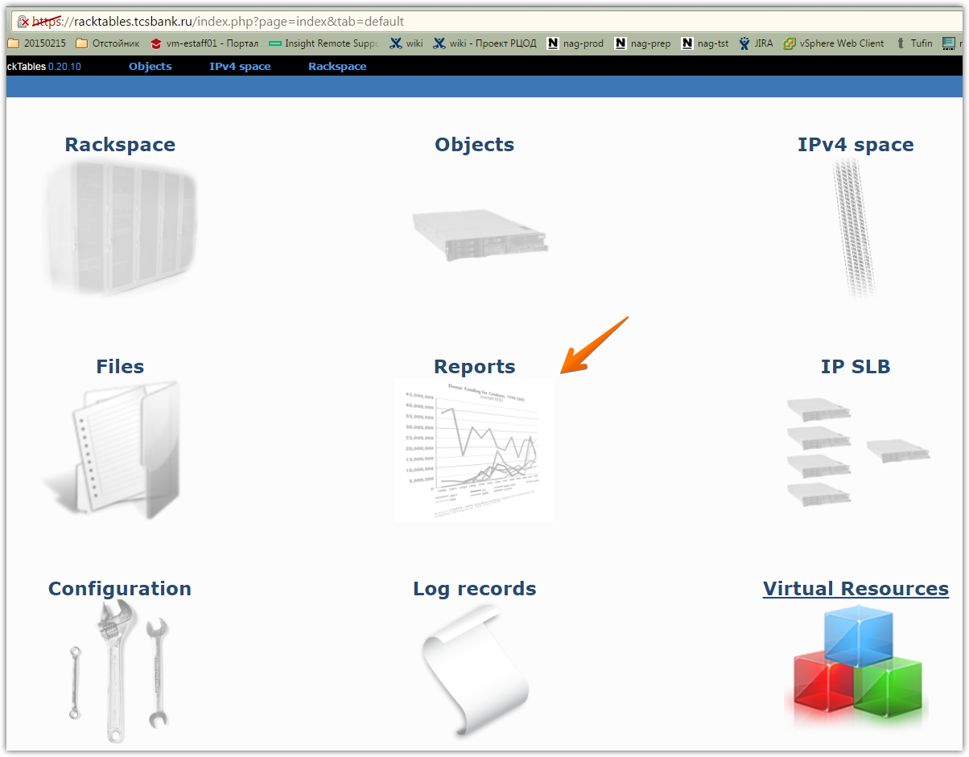

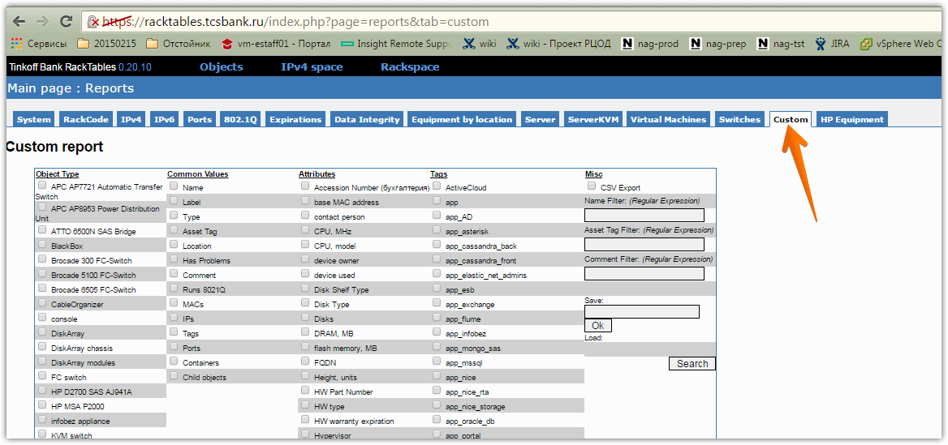

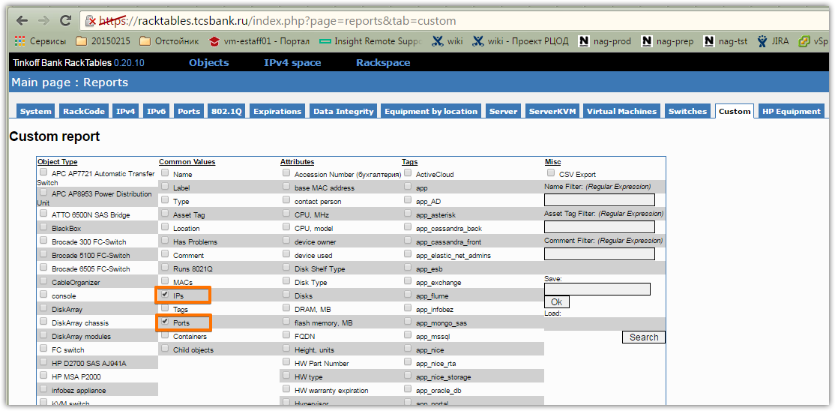

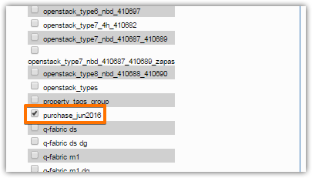

# Here is a result, what we have.
